**NAMA : Dino Ariel Ihsan Saputra**

**NRP : 3124500053**

**KELAS : 1 D3 IT B**

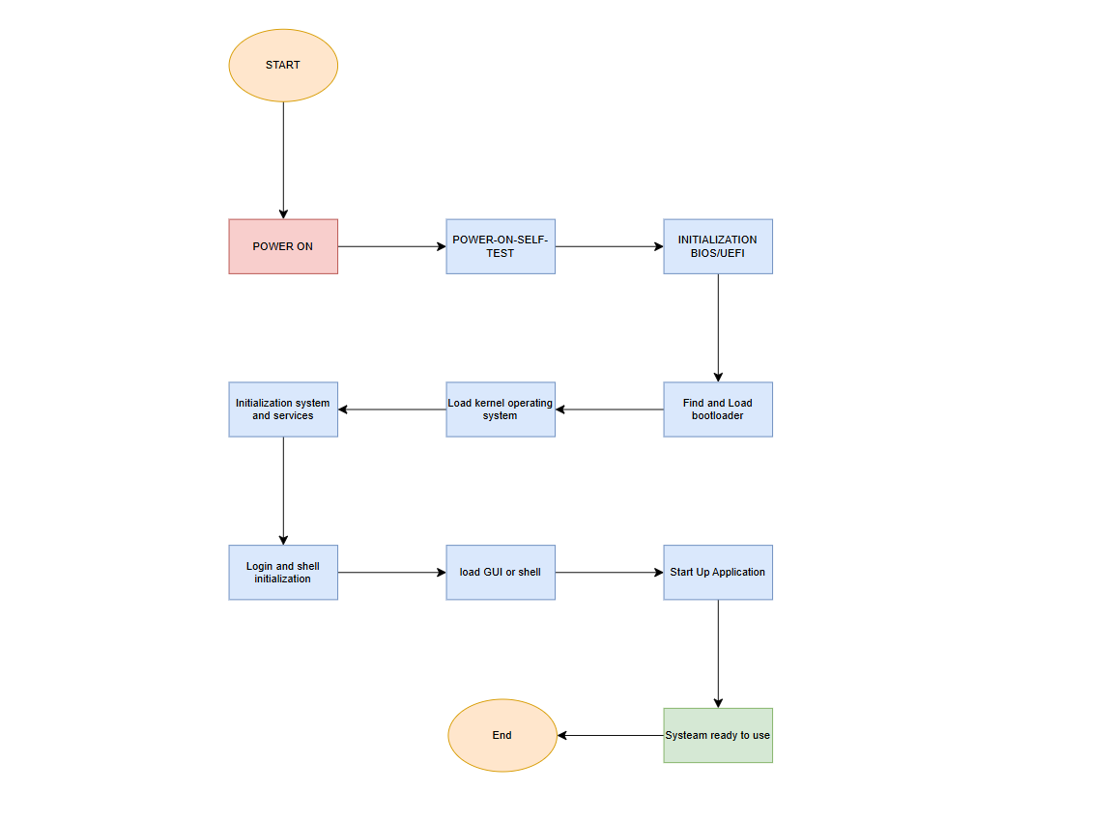

1. **POWER ON**: The computer is powered on.
2. **POWER-ON-SELF-TEST (POST)**: The computer performs an initial diagnostic test to ensure all hardware components are functioning correctly.
3. **INITIALIZATION/ BIOS/UEFI**: The system begins the initialization process. This is likely a typographical error, intended to be "BIOS" (Basic Input/Output System). BIOS is firmware responsible for starting the hardware and loading the operating system.
4. **Initialization system**: The system proceeds with further initialization.
5. **Load kernel operating**: The operating system kernel is loaded into memory. The kernel is the core of the operating system, managing system resources.
6. **Find and Load and services**: The system searches for and loads necessary services for system operation.
7. **biodloader**: This is likely a typographical error, intended to be "bootloader". The bootloader is a program that loads the operating system into memory.
8. **Login and shell**: The system prompts the user to log in and loads the shell (command-line interface).
9. **installization**: This is likely a typographical error, intended to be "initialization". Further initialization processes are carried out.
10. **load GUI or shell**: The system loads the graphical user interface (GUI) or shell, depending on the system configuration.
11. **Start Up Application**: Applications configured to run at startup are launched.
12. **System ready to use**: The system is ready for user interaction.